SAP CPI Project “ SOAP to SOAP “
Dummy URL for testing http://dneonline.com/calculator.asmx?wsdl
- Save as file as .wsdl from above URL
- Sender
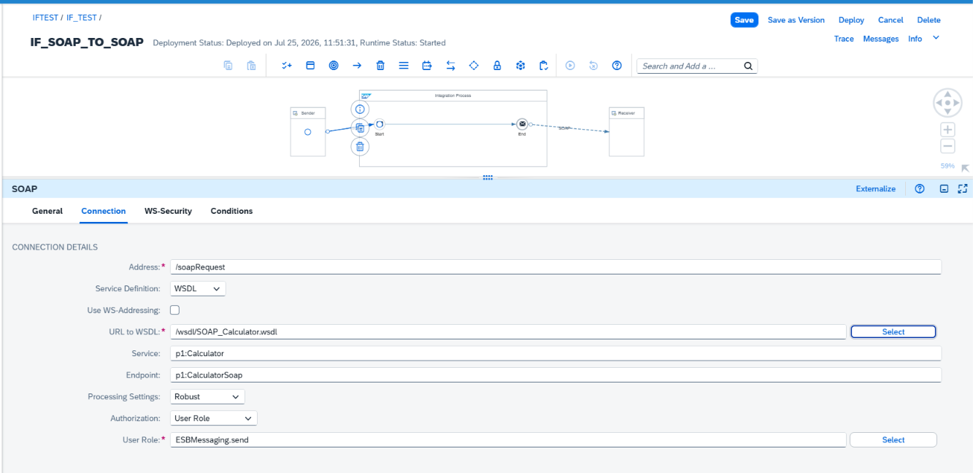
- Select saved wsdl file in URL to WSDL using Select Button as shown in picture
- Select Service what you want to do as mention image below

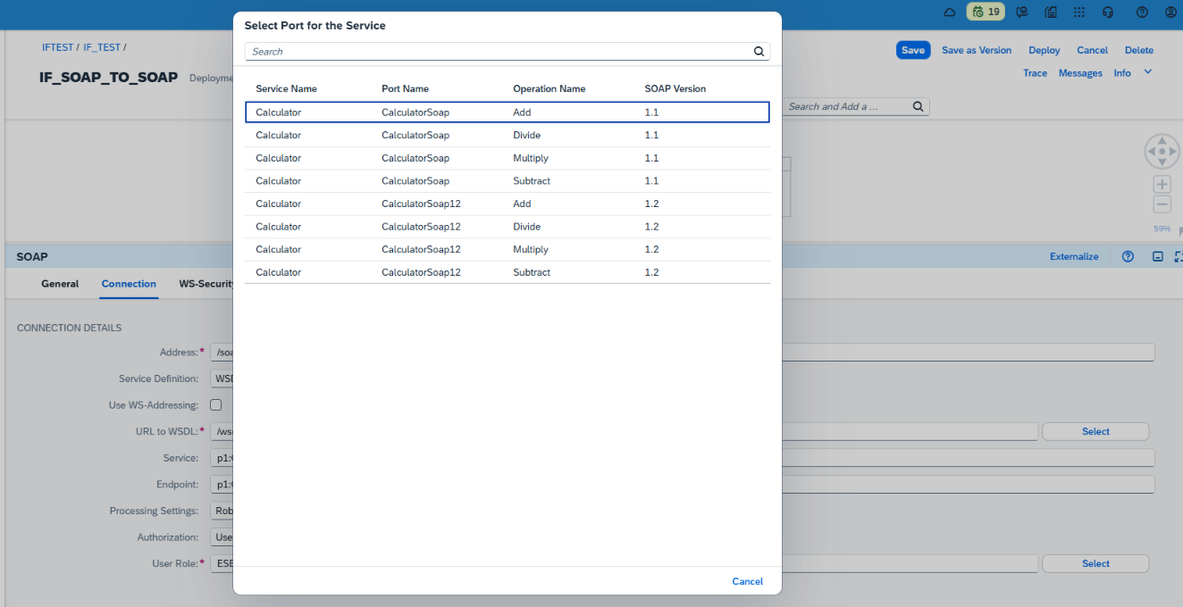
- Keep fields as it is as mention in Image.
- Receiver
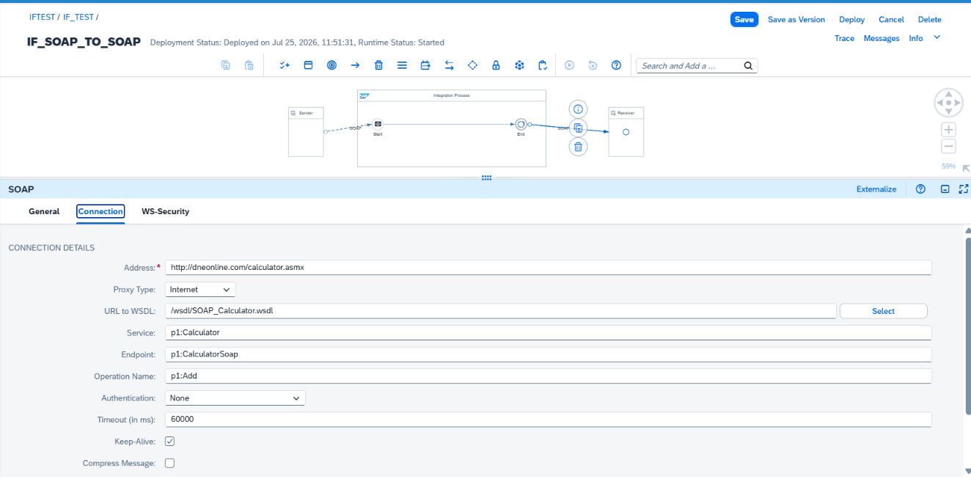

- Add address
http://dneonline.com/calculator.asmx

- Select saved wsdl file in URL to WSDL using Select Button as shown in picture
- Select Service what you want to do as mention image below


- Keep fields as it is as mention in Image.
- Send SOAP Request from Postman using BTP Credentials
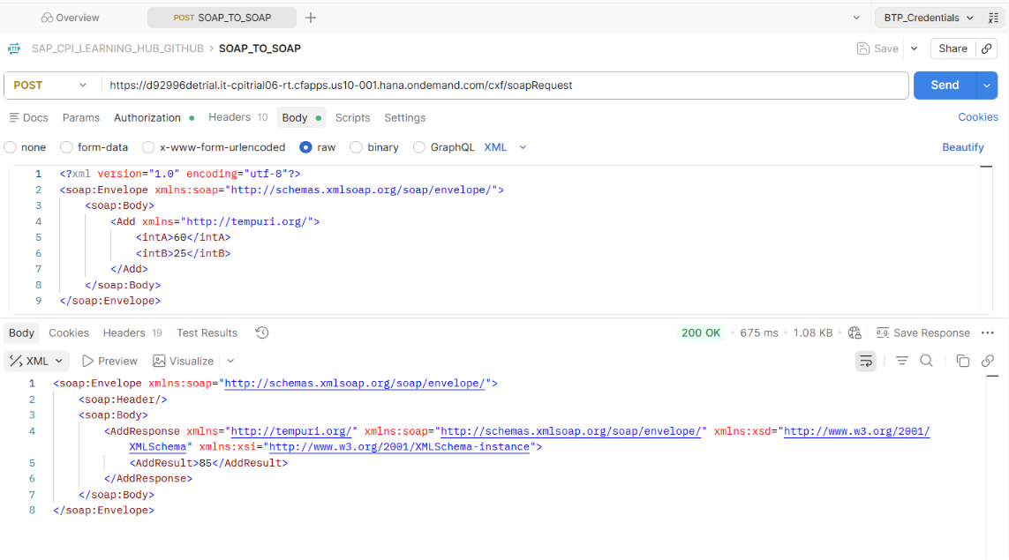
- Find Postman Collection in Github

